Name

Teacher

Class

Date

Living With Asthma

Why I Want to Know/What I Already Knew /What I Wanted to Know

“Well, Annie, it looks like you have asthma,” our family physician informed me. I could not believe what I was hearing. I thought that I had been suffering from a very stubborn cold. Questions started going through my head as I listened to Dr. Davis explain my condition. I’m in high school. Aren’t I too old to get asthma now? How can I stay on the softball team? Will I still be able to go on camping and hiking trips with my family?
I already knew that asthma is a chronic disease which affects the lungs and that certain medications help control the number and severity of asthma episodes. (That’s when the coughing and wheezing start.) I didn’t know much more than that.
I needed to know more about what might trigger an asthma episode. Will I be able to keep up with other players on the softball team? Are there certain types of trees and plants that I should avoid? After much pleading and negotiating on my part, my parents had finally agreed that our family could have a dog. Will I be able to live with it? I made a list of the things I needed to know. From that list, I was able to form my research question: Can I effectively manage my asthma? Later, I was able to form an answer.
The Story of My Search
My search took about two weeks. I began my research by doing some background reading at WebMD, the health and medical news and information website. That site provided a definition of the term asthma, information on how the lungs function, the causes of asthma attacks, and the diagnosis and treatment of the disease. Statistics on the number of Americans with the disease were included in the article. Most of the information, including the statistics was supported by the information in the Merck Manual of Medical Information.
From there I did an online search combining the terms asthma and managing in the Google search engine. It gave me a street address at which I could contact the American Lung Association, as well as the date the site was last updated.
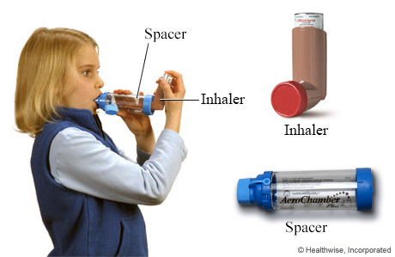
Dr. Davis referred me to an allergy / asthma specialist named Dr. Emma Anders. Since she was going to treat my asthma, I decided to interview her for my paper. I forgot to take her busy schedule into account, and I did not know that she had planned a short vacation during the time I was doing my research. She graciously agreed to meet with me after her office hours one day. Dr. Anders was a great source of information on all aspects of my disease, but the most unique feature of our interview included a demonstration of two instruments, a metered-dose inhaler and a spacer. She also sent home a video on the appropriate use of both pieces of equipment.
During the next week I went to my school library. My school librarian directed me to the reference section where were many specialized medical encyclopedias. I chose to use the Merck Manual of Medical Information because it was the most current publication on the shelf. The vocabulary was much more technical than what I had found in the other sources. Included in the article were a table that showed the different medications used to treat asthma and a graphic that illustrated the correct use of an inhaler. Using the library’s OPAC (Online Public Access Catalog) to search for books, I did a subject search using the term asthma. My school library didn’t have any titles that dealt with asthma. I realized that I would have to go to the public library to find books.
Still at my school library, I talked to our school librarian about using Proquest, a very comprehensive online magazine / newspaper database. Our librarian showed me how to use the “Browse Topics” feature. This feature allowed me to find the search terms used by Proquest and to narrow my search. I found asthma listed as a search term with 111 subtopics. I narrowed my search by adding the subtopic athletes to one of my searches and allergies to another.
At the public library I searched the OPAC (Online Public Access Catalog) using asthma as the search term in a subject search. Surprisingly, many of the titles shown in the catalog were checked out. I didn’t want to place any titles from other libraries on hold, so I checked out 1 of the 2 titles on the shelf. The book, Breathe Right Now: A Comprehensive Guide to Understanding and Treating the Most common Breathing Disorders, was much longer that I had anticipated. Consequently, I read only some of the chapters.
By the end of the second week, I felt I had plenty of information. My original search question remained the same: Can I manage my asthma? I was able to define exactly what it was that I wanted to manage. I ended up narrowing my topic to three areas I had to deal with in order to manage my asthma: medications, sports/exercise, and environmental factors.
The Search Results
According to the information at WebMD, many Americans, besides me, have asthma and that number has increased dramatically in the last 20 years. “ More than 17 million Americans suffer from asthma, with nearly 5 million cases occurring in children under age 18. In the United States, asthma causes 5,500 deaths each year… Among all Americans, the prevalence of asthma increased more than 60 percent between 1982 and 1994.” (1) The management of asthma is a health issue for many people besides me. As a result of my research I have found that I can manage my asthma and live a full, active life by minimizing the effects of environmental factors that can trigger asthma episodes, following my physician’s instructions about medications and by sticking to an exercise program.
Numerous substances can trigger an asthma attack of coughing, wheezing, and shortness of breath. Allergens constitute the largest category of triggers (Abramowicz). According to Susan Berg, “Allergens are substances that produce an allergic reaction in people who are sensitive to them.” Common allergens are pollens from plants, animal dander, dust mites, mold and mildew (23). Dr. Anders said we would do a series of skin tests for allergies right away. If I am allergic to certain triggers, allergy shots will help by desensitizing me to them, making them less likely to trigger an episode (Anders).
If I am allergic to certain pollens, I can reduce the chances of an asthma episode by staying indoors when those pollens are in the air. Indoors, I can reduce the risk of an episode by using the air conditioner to circulate air while keeping windows and doors closed to keep pollens out. Cleaning the air with an air cleaning device can reduce dust mites, mold sporse, and other indoor allergens (“85 % of Americans”).
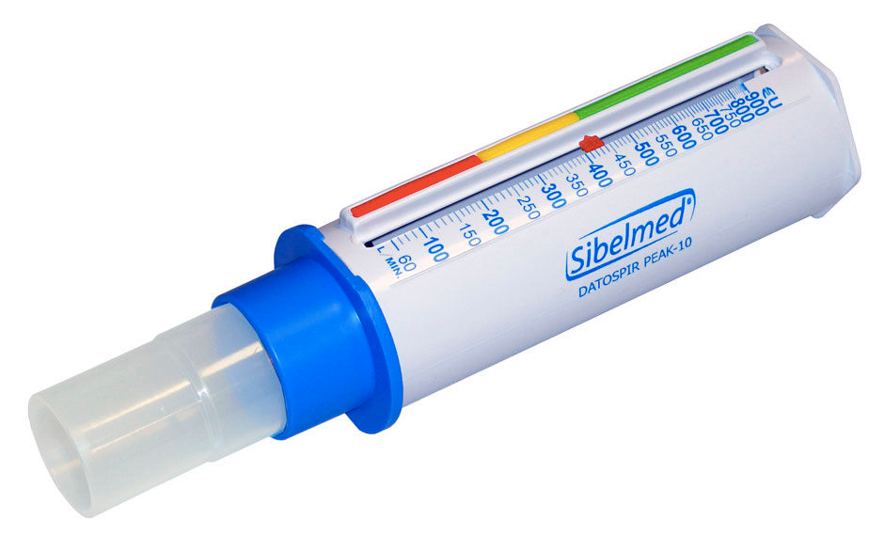
Two instruments are commonly used in the treatment of asthma. The first is called a peak flow meter. This is a tube about six inches long; its purpose is to measure your ability to push air out of your lungs. When you exhale into it, you can determine if your lungs are working at their capacity. If they are not, you know it is time to take some medication, often with a metered-dose inhaler (Peak Flow Meters). A metered-dose inhaler, a hand-held pump, delivers medication directly to the airways and helps patients get their breath back very quickly (Anders).
There are many different medications that doctors may use to help people with asthma. Medications can be injected, taken orally or inhaled. Inhaled medications are usually a first line of defense because they work very quickly, usually in less than 5 minutes. This is because they go right into the lungs and not into other parts of the body. Certain anti-inflammatory drugs are used to keep air passages open and prevent asthma episodes. One type of these is called corticosteroids. I was relieved to find that these are not the same kind of steroids that cause serious side effects in athletes . The risk of side effects with corticosteroids is very small. (Asthma Medicines).
Twenty or thirty years ago doctors believed that physical exercise made an asthmatic patient’s condition worse. At that time doctors believed a quiet, restful life was best. Now new research is showing that “people with breathing disorders who can maintain a regular program of exercise and activity are able to experience maximum cardiovascular fitness along with greater symptom control, or an increased ability to exercise and do the activities of daily living. Exercise trains the respiratory muscles to work more efficiently” (Smolley and Bruce,127-128). I had been worried that I would have to drop off the softball team or miss our next family camping trip. These facts, however, made me confident that I would be able to continue to do both.
Nancy Hogshead, a former Olympic athlete, demonstrates some exercises for asthmatics on a video called Aerobics For Athletes. I tried some of the exercises, and they are great. Nancy serves as a wonderful role model. She and other Olympic athletes including Rob Muzzio, Jim Ryun, Jackie Joyner-Kersee, and Amy VanDyken have had to deal with asthma, and many of these athletes still compete (Smolley and Bruce128). In fact, a recent study of Olympic athletes revealed that “more than 20 percent of the American athletes who participated in the 1996 Summer Olympic games may have had asthma” (Olympians”). I am very encouraged by this fact.
After doing the research, I concluded that if I developed a plan for myself, I would be able to manage my asthma. My plan addresses the areas of medical treatment, environment, pets and sports. If I find that I have allergies, I’ll take the allergy shots. I’ll take my medications and monitor the peak flow levels every day as well as go in for checkups every three months. Prior to outdoor activities such as hiking and camping I’ll have to check the pollen counts that are published in our local newspaper. If the counts are high, I won’t be able to participate. As for getting a dog, our family will have to postpone that decision until I’ve found if I’m allergic to them. Finally, I can continue to participate in my sports and physical activities. I’ll use the peak flow meter before and after softball games, do warm-up breathing exercises, and keep an inhaler handy for emergency use.
Reflection: My Growth As A Researcher
I actually learned a lot about doing research as a result of this project. For one thing, doing the research took a lot more time than I thought it would. Consequently, I have learned to plan my time more efficiently. I’ll schedule an appointment well ahead the next time I want to interview someone. My writing skills also improved. I learned to use an outline to organize my thoughts before I begin to write. I’m also better able to write a well-developed paragraph that focuses on one topic. Proquest and the OPAC at the public library are both tools that I hadn’t used before but will use with my next research project. I also learned how to evaluate information from web sites. In addition to these academic benefits, I got a lot of information that will help me lead a full and active life, in spite of my asthma.

Works Cited
Aerobics for Asthmatics. Videocassette. Allergy and Asthma Network / Mothers of Asthmatics, Inc., 1993.
Anders, Emma R., M.C. Personal interview. 12 Apr. 1999.
“Asthma.” The Merck Manual of Medical Information. Whitehouse Station: N.J. Merck Research Laboratories, 2003.
“Asthma Medicines.” American Lung Association Web site. American Lung Assocition. 15 Apr. 1999. <http://www.lungusa.org / asathma / astasmeds2.html>.
Berg, Susan. “Recently Diagnosed with Asthma?” Asthma Mar.-Apr. 1999: 22-24.
“85% of Americans Don’t Know the Air in Their Homes May Be Hazardous to Their Health.” American Lung Association Web site. 24 Mar. 1999. American Lung Association. 15 Apr. 1999. <http://www.lungusa.org/press/association/85percent.html>.
“Olympians Don’t Let Asthma Hold Them Back.” Asthma Mar.-Apr. 1999: 15.
“Peak Flow Meters.” American Lung Association Web site. American Lung Association. 15 Apr. 1999. <http://www.lungusa.org/asthma/astpeakflow.html>.
Smolley, Laurence A. and Debra Fulghum Bruce. Breathe Right Now: A comprehensive Guide to Undertand and Treating the Most common Breathing Disorders. New York: Norton, 1981.

