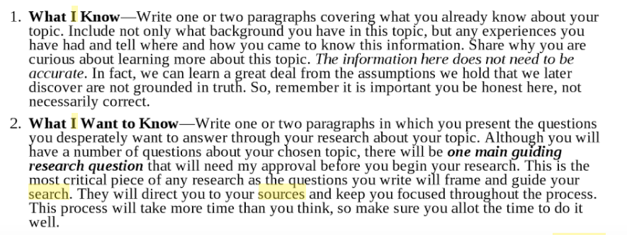
Assignment for our next class: Go to your Google Doc, and write the first 3 sections. In the graphic below, parts 1 and 2 are combined (why I chose it=my experience with it,and what I already know) in #1. Follow the guidelines for length that we added to the Google Doc.
Part IV. The Story of My Search

Albert Einstein said, "If we knew what it was we were doing, it would not be called research, would it?”

After you have identified your topic, written your hook, written what you already know about the topic and why you need to know about it, you are ready to begin your research! PLEASE don’t begin reading and studying the research UNTIL you write all of the Introduction requirements so you don’t change any of the preconceived notions that you already have about your topic.

The Research Journey will, by far, take the bulk of your time. In this section you will report out on the information you discover. This is where you will spend much of your time searching, critically reading, and synthesizing new knowledge with old knowledge. Questions will be answered and new questions will arise. A great deal of time will be spent BEFORE you even begin writing because for each of the 4 print sources, you will
- create the MLA citation in Easy Bib
- describe how you discover the source
- describe the process you used to evaluate the source
- summarize the source
- describe what questions were answered and what questions were raised and what knew knowledge was discovered

Read what experts have to say about your topic!

You will be required to utilize 5 sources for this paper. That means you should LOCATE twice that because they may not all be usable.
1 interview with an expert
2 website articles
2 database articles (EBSCO and/or ProQuest)

How do you know which sources are GOOD sources?
**We will use a tool to evaluate the validity and trustworthiness of your print sources.
But first, view http://nova.campusguides.com/evaluate

Now that we know how to evaluate a source, let’s go find some sources! Follow these steps to access the databases you will be required to use for research next year.

- Go to http://siouxlandlib.polarislibrary.com/polaris/
- On menu on left side of screen Select Research a Topic
- Select Databases and Selected Websites
- Scroll down and select the EBSCO Metafile
- You will now be prompted to enter your Siouxland Library Card number and your PIN
- Click Log In
- I will be demonstrating with my husband’s golf ball dimples topic! How do the dimples on a golf ball affect his golf game?
- Be sure to check the Full Text option so you find full articles and not just abstracts or summaries
- Begin by clicking on the Advanced Search under the search box
- Type in 2 or 3 search terms to narrow your topic.
- I will use golf ball, dimple, lift
- If you have more than 20 articles, narrow your search terms
- I found 3 articles. Skim the abstracts and the articles carefully to see which ones best answer your question.
- If you believe this is a source you could utilize, print it using the Print command in the menu on the right. Before printing, be sure to click Full Text and change citation to MLA
- To Cite it right away, open a new tab and Log In to EasyBib
- Click New Project and name it I-Search Paper. BE SURE TO CHOOSE MLA8, not MLA7!
- Click on Bibliography to OPEN that I-Search Paper Project
- Go back to EBSCO article
- Click the Cite button on the menu on the right.
- Scroll down to MLA
- Click Export on the menu on the right.
- Choose the very last bubble in the list “Direct Export to EasyBib”
- Click Save.
- EasyBib will open. Be sure to import Without abstracts
- Now go back to EBSCO and survey the articles from your search. TAKE YOUR TIME to Select AT LEAST FIVE that look like they might be helpful. Follow steps 19-24 to export them into your EasyBib, then go ahead and print the articles once you decide they are worthwhile.
26. By the time you finish, you should have FIVE article in your EasyBib I-Search Project!

Place all of the article that you find in your research folder.

